1. Check system information

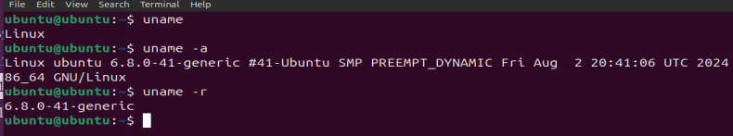

1. Manage users (create, delete, modify)

C:\Users\PC\Pictures\Capture 2.PNG

1. Manage groups (create, delete, modify)

C:\Users\PC\Pictures\Capture 3.PNG

1. Change user passwords

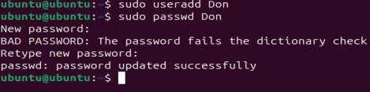

1. Create, rename, move, and delete files

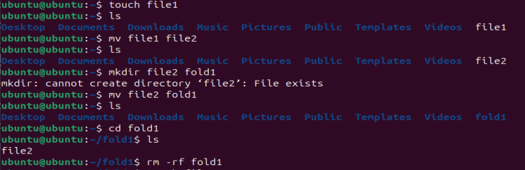

1. Create, rename, move, and delete directories

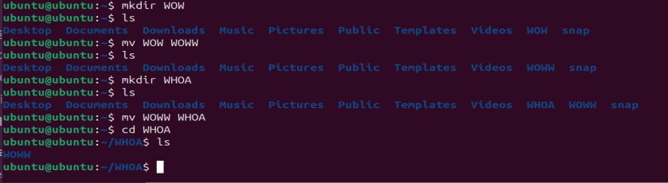

1. Change file permissions

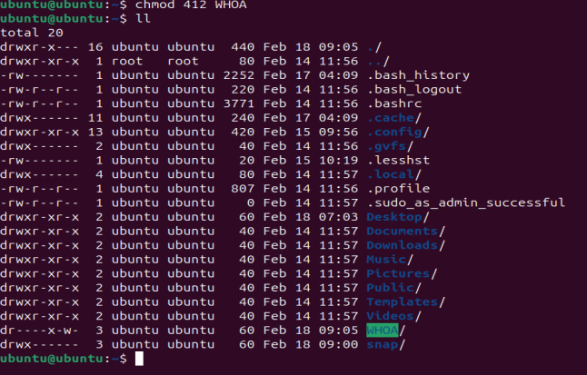

1. Change file ownership

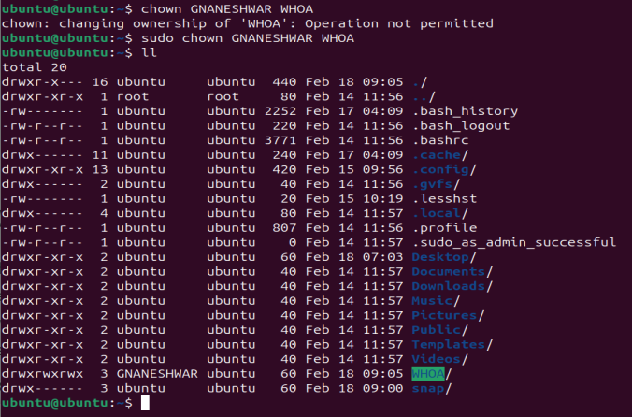

1. View running processes

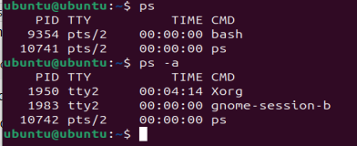

1. Kill a process by PID or name

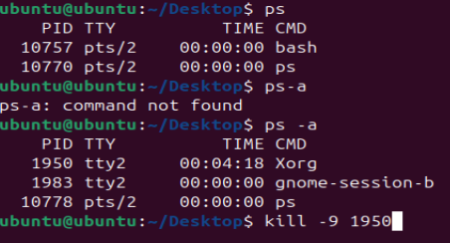

1. Check disk usage and free space

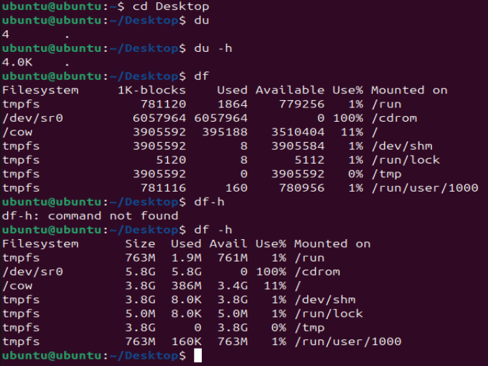

1. Monitor system performance (CPU, memory usage)

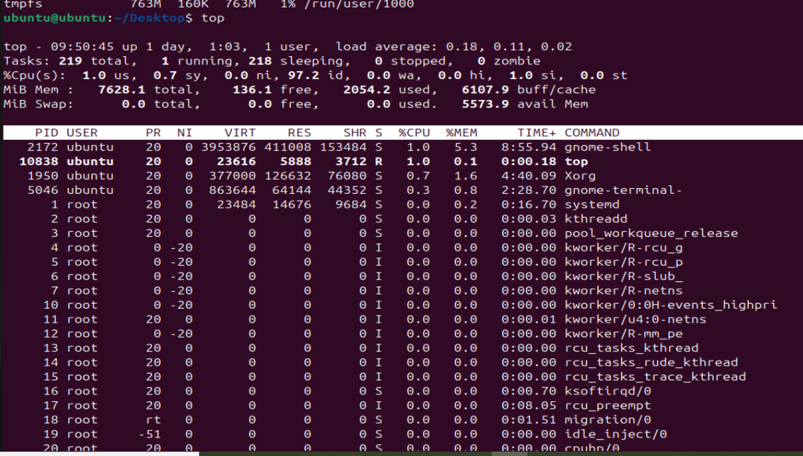

1. Install and remove packages using a package manage

Git install:

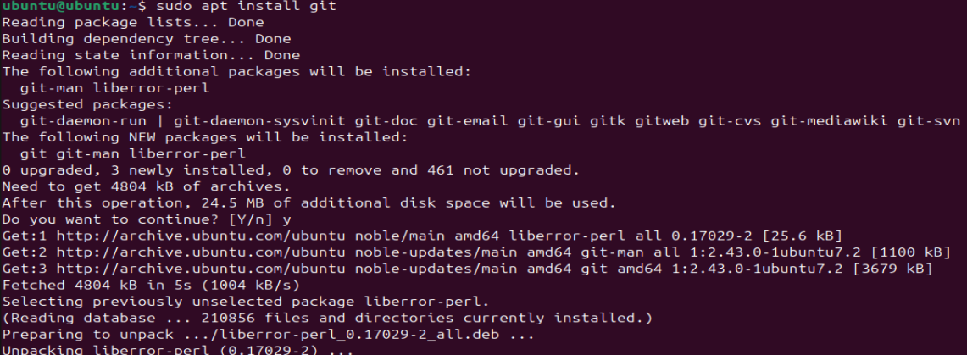

Git remove:

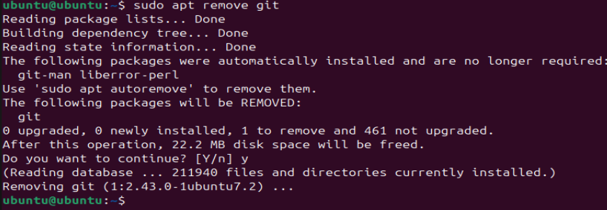

1. Configure and check network settings

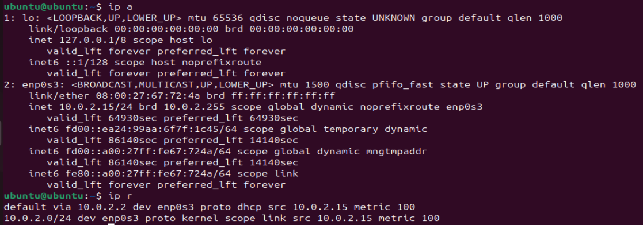

1. View and analyze system logs

